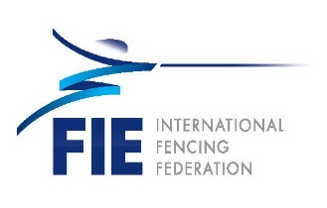
QATAR FENCING FEDERATION
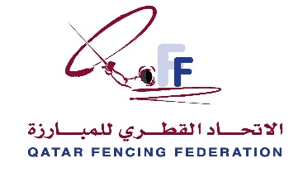
Fencing GRAND PRIX QATAR 2021

FOIL – Men & Women– SENIOR – INDIVIDUAL

DOHA – QATAR – 26 to 28 March 2021
Form to be sent to:

Organizing Committee / Host Federation
Qatar Fencing Federation
Contact Person: Mrs Nesreen
E-mail: visaqatgp21@gmail.com
Office (direct): +974 4494 4158

Deadline: as soon as possible and at least before 05/03/2021
ExCEPTIONAL ENTRY PERMIT (EEP) REQUEST Form

Federation |  | Contact person
 |  | Phone
 |  | E-mail

LAST NAME  First name | Function | Gender  M/F | Date of birth  dd.mm.yyyy | Citizenship /  passport N° | Passport expiry date | Arrival date | Departure date | Departure Country*
* departure country which will be mentioned on the Exceptional Entry Permit

Place and date | Seal of the NF | NF authorised signature
 |  | Signature of the President or Secretary General of the FIE affiliated NF

