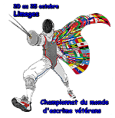 | 19ème Championnats du Monde Vétérans  Limoges – France  20 – 25 Octobre 2015  2015 Limoges Veterans Fencing World Championships

DISCHARGE OF RESPONSIBILITY

WAIVER OF LIABILITY

Upon entering this tournament under the auspices of the French Fencing Federation and the FIE, I declare that I am in a fit state of health to participate and agree to abide the current rules of the FIE.

I enter this tournament at my own risk and release the FIE, the French Fencing Federation and its sponsors, referees, and tournament organisers from any liability.

Date……………………………….

Signed……………………………..

Print name……………………………..

