Dutch Open Coubertin Cup 2015
Concept

Events and Venues
Saturday September 19th, Arnhem
Technical Meeting  07.30 h  SOOlancelot  Olympus 25  6832 EP Arnhem | 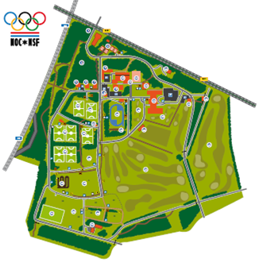
Fencing (A)

08.30 – 10.45 h

Sign up/appél: 08.30 h -09.00 h
Scratch: 09.15 h
Start event: 09.30 h

SV Scaramouche
Olympus 29
6832 EP Arnhem
Swimming (A)

12.30 - 13.30 h

Sign up: 12.00 h at the main entrance
Warming-up: 12.10 - 12.30 h
Start event: 12.30

De grote koppel
Olympus 29
6832 EP Arnhem
Horse Riding (B) Red

14.30- 17.00 h

Sign up: 14.15 h
Start event: 14.30 - 17.00 h

National Sportcentre Papendal Papendallaan 3 6816 VD Arnhem
Combined (B) Yellow
Athletics track
17.15 - 18.30 h

National Sportcentre Papendal Papendallaan 3 6816 VD Arnhem

