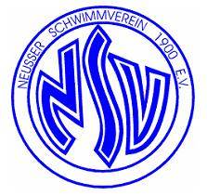
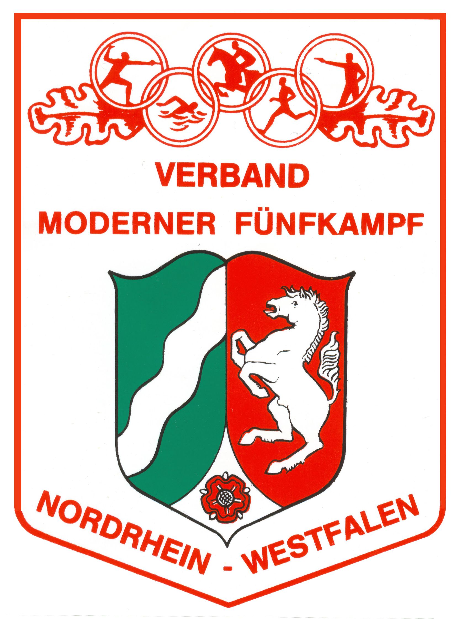

Announcement
International Nordrhein Westfälische
Classic Master – Competition Tetrathlon and Pentathlon
from 09. to 11. May 2014 to Neuss

Organiser: German Pentathlon Association NRW
Neusser Schwimm Verein e.V.

Participants: Master Women/Men

Modus: 4K, 5K, Women and Men, separat judgment

Rules : Rules and regulations of the UIPM veteran competitions apply.
Organisers reserve the right to change the program

Entry: Entry deadline: 14.04.2013 to contact Horst Bebber,
Email: bebber.horst@web.de , Phone Nr. (0049)2131/101222
After 14.04.2013 is it not possible to give guarantee for room or riding

Fees: Pentathlon 110,-€, Tetrathlon 55,-€, Escort Person 30,-€
Incl. Food (2 x Breakfast, 2 x Dinner, 1 x Lunchboxes)

Accommodation: 1 night double room per Person 25,-€
1 night single room 30,-€

Time and Location: Nordpark Bad, Neusser Weyhe 14 -16, 41462 Neuss (meeting point)

Hotel: Kolpinghaus, Burggraben 1, 41460 Neuss, Attention: no Towels

Routing: Highway 57 Köln-Krefeld, Exit Number.18

Program: Friday 09.: Registration beginning at 15:00Uhr, handing over of the room keys
Technical Meeting -> Nordpark Bad club home,
Shooting -> Nordpark Bad basement,
Swimming -> Nordpark Bad,
Dinner -> Nordpark Bad club home,
Saturday 10.: Breakfast -> Nordpark Bad club home,
Fencing -> Sport Centrum Karrenbergschule vis-à-vis Nordpark Bad
Riding -> Gestüt Gut Neuhaus, Familie Tillmann, 41516 Grevenbroich – Neukirchen
Running (Spikes possible) -> Nordpark Bad,
Afterwards award ceremony and dinner -> Nordpark Bad club home
Sunday 11.: Breakfast -> Nordpark Bad club home, afterwards departure

Others: Organisers reserve the right to change the program.
Fencing gear according to FIE, Everyone participates at their own risk.
Organisers will not take responsibility for any damages (if occurs) and
they will not compensate them either.
Horse riding: Disclaimer for organizers and riding stables

Pentathlets have to pay 70€ in advance due to the organisation of the horses.
Account: Horst Bebber, Account Number:103074544 Bank code 37060590,
Sparda Bank West IBAN: DE73 3706 0590 0103 0745 44, SWIFT-BIC: GENODED1SPK

Please use the attached entry form

Neuss, the 28.02.2014

Horst Bebber, Winni Kettler

Registration
(for each Person)

International Nordrhein Westfälische
Classic Master – Competition Tetrathlon and Pentathlon
from 09. to 11. May 2014 in Neuss

 | Please make her „X“ only
Competition: |  | 4K  5K
Name:
First name:
Country (short form)
Births date: (Year)
E-mail Adresse:
Swim time |  | 50m = _____sec. or  100m = _____ sec.
Number of Overnight: |  | 1  2  3  by 3 Overnight Arrival  Date:  Time:
Room for Overnight |  | Single room  or  Double Room  Name of companion:
Participation of:
Dinner Friday 09.05. |  | Yes  No
Breakfast Saturday 10.05. |  | Yes  No
Dinner Saturday 10.05. |  | Yes  No
Breakfast Sunday 11.05. |  | Yes  No

